Calculator Free
Logarithmic Graphs and Differentiation

Time: 45 minutes
Total Marks: 45
Your Score: / 45



Question One: [2, 3, 2 = 7 marks] CF

Consider the exponential function drawn below.

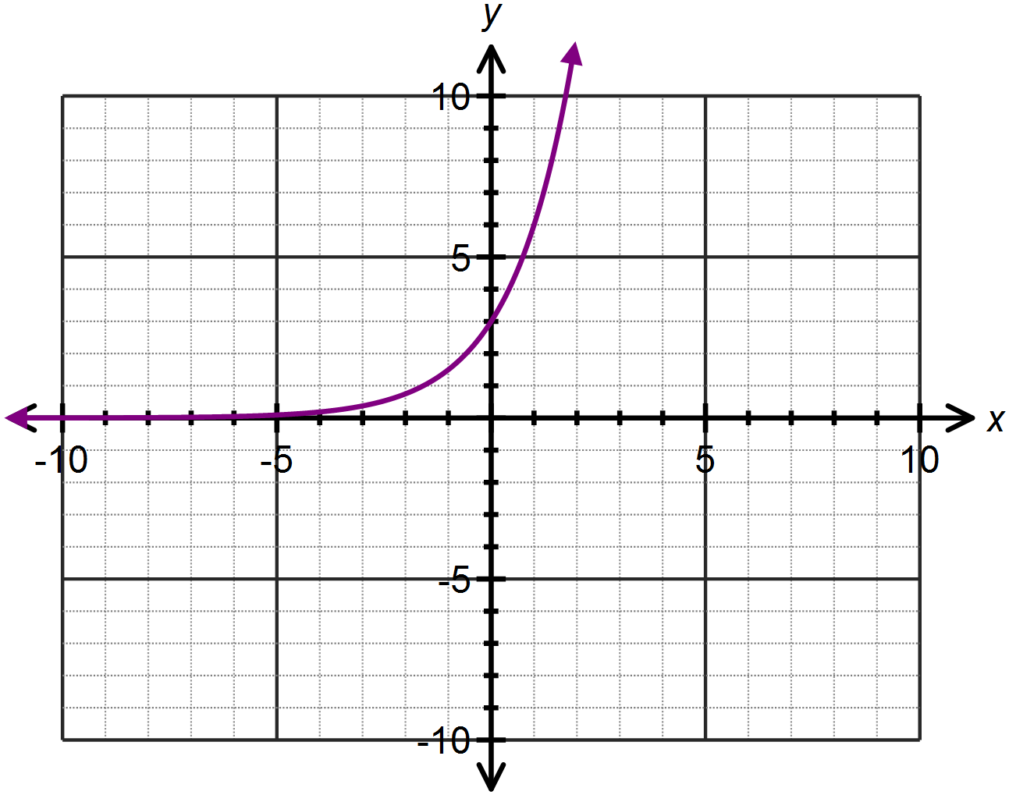

- State the equation of the exponential function in the form .

- Use the exponential graph drawn, and an appropriate mirror line, to draw the logarithmic function which is the inverse of the given exponential function.

- Hence or otherwise determine the equation of the logarithmic function, which is the inverse of the given exponential function with the same base.

Question Two: [2, 3, 3 = 8 marks] CF

Determine the equation of each of the following graphs drawn below:
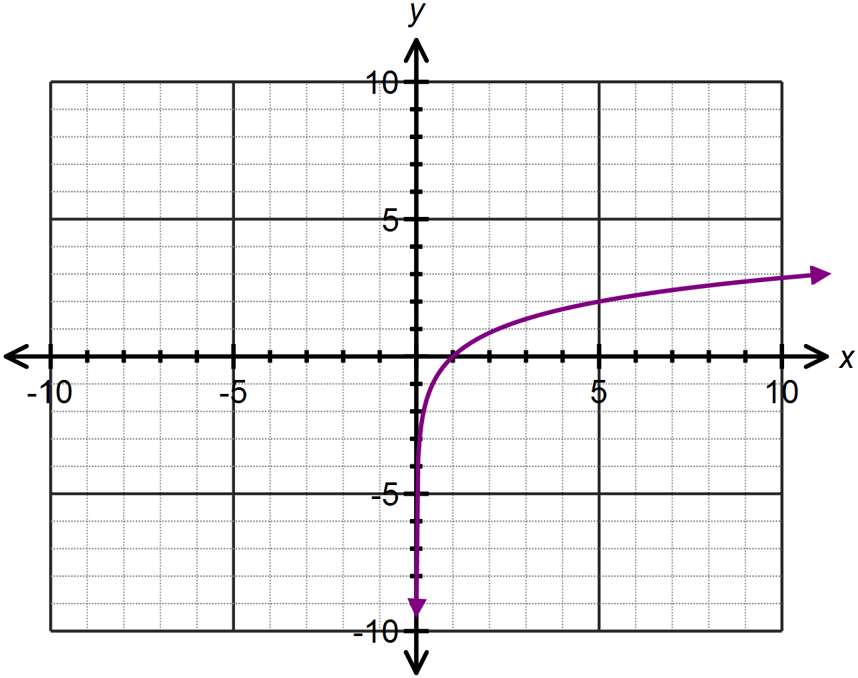

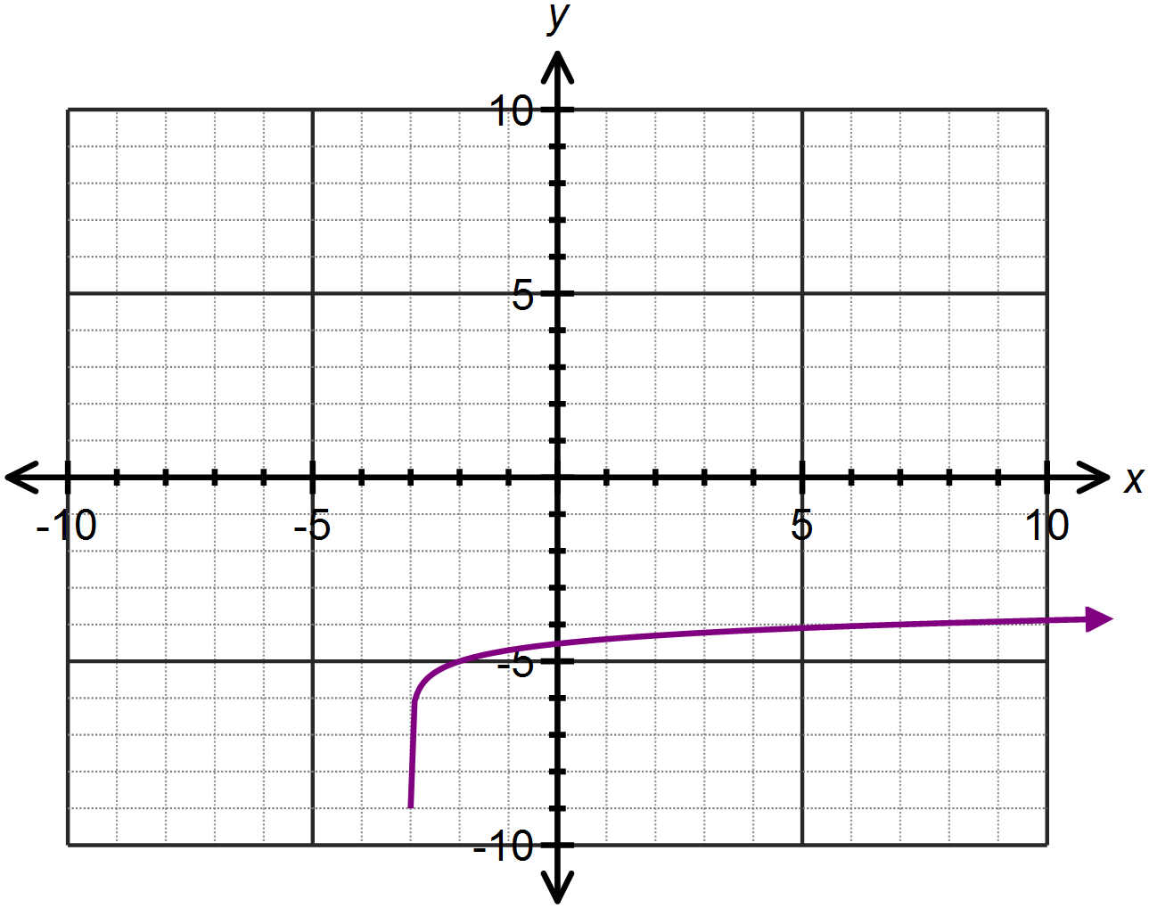

(b)

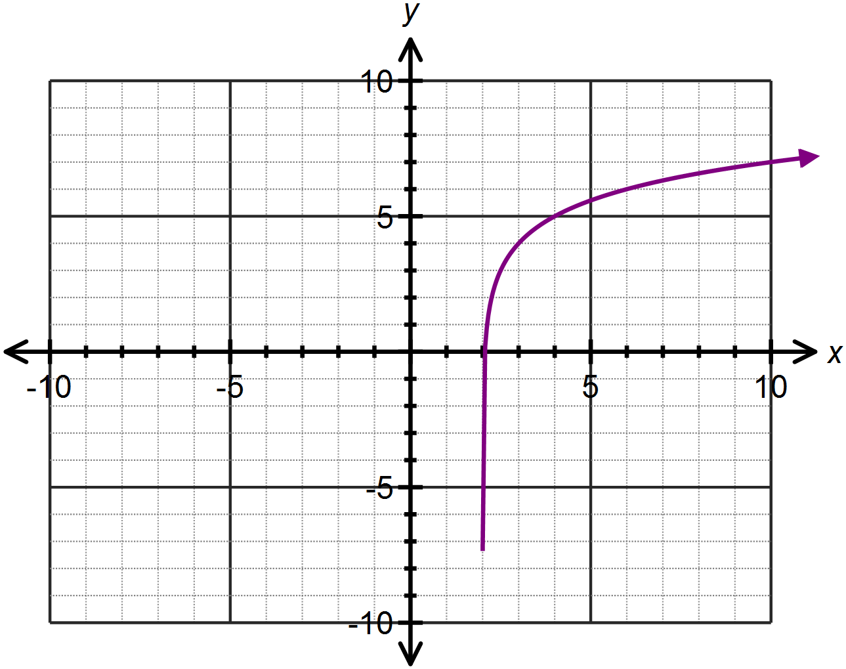(c)

Question Three: [2, 1, 2 = 5 marks] CF
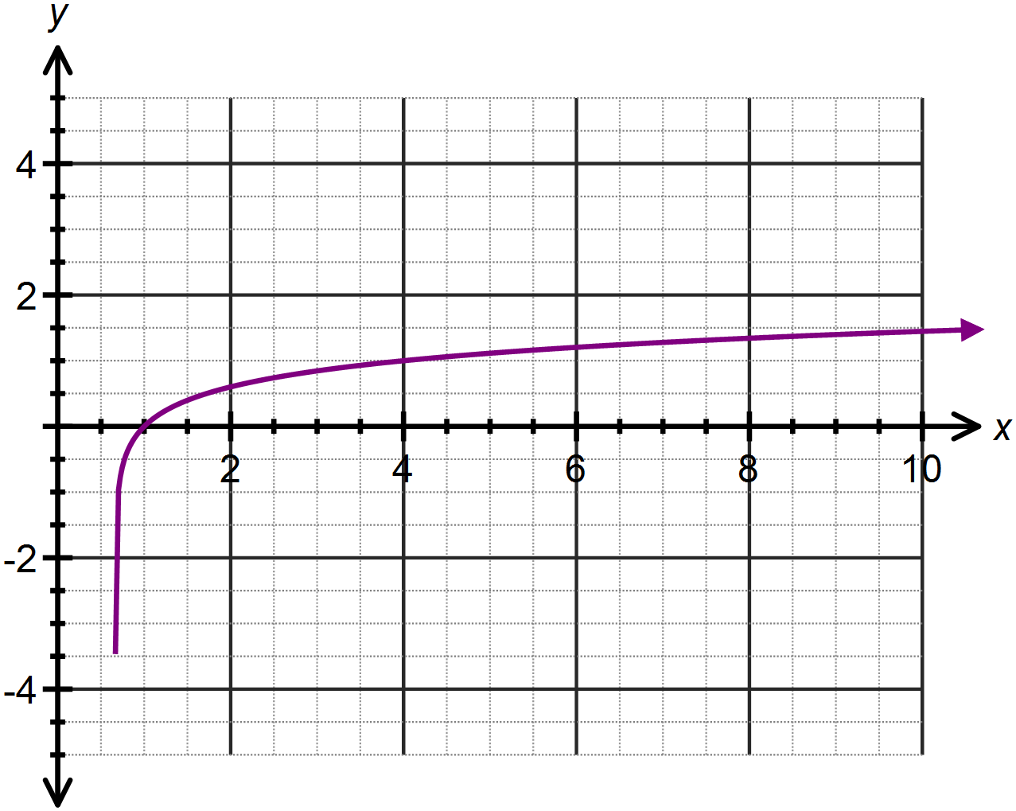The function is drawn below.

(a) Determine the value of a.

(b) Use the graph to approximate the solution to

(c) Solve algebraically.

Question Four: [1, 3, 3, 2, 3, 3 = 15 marks] CF

Differentiate each of the following with respect to x, showing full working:

(a)

(b)

(c)

(d)

(e)

(f)

Question Five: [5, 5 = 10 marks] CF

(a) Determine the coordinates of the point(s) where the curve has a gradient of 2.

(b) Determine the equation of the tangent to the curve at the point where . Leave your answers as exact simplified values.
SOLUTIONS
Calculator Free
Logarithmic Graphs and Differentiation

Time: 45 minutes
Total Marks: 45
Your Score: / 45



Question One: [2, 3, 2 = 7 marks] CF

Consider the exponential function drawn below.

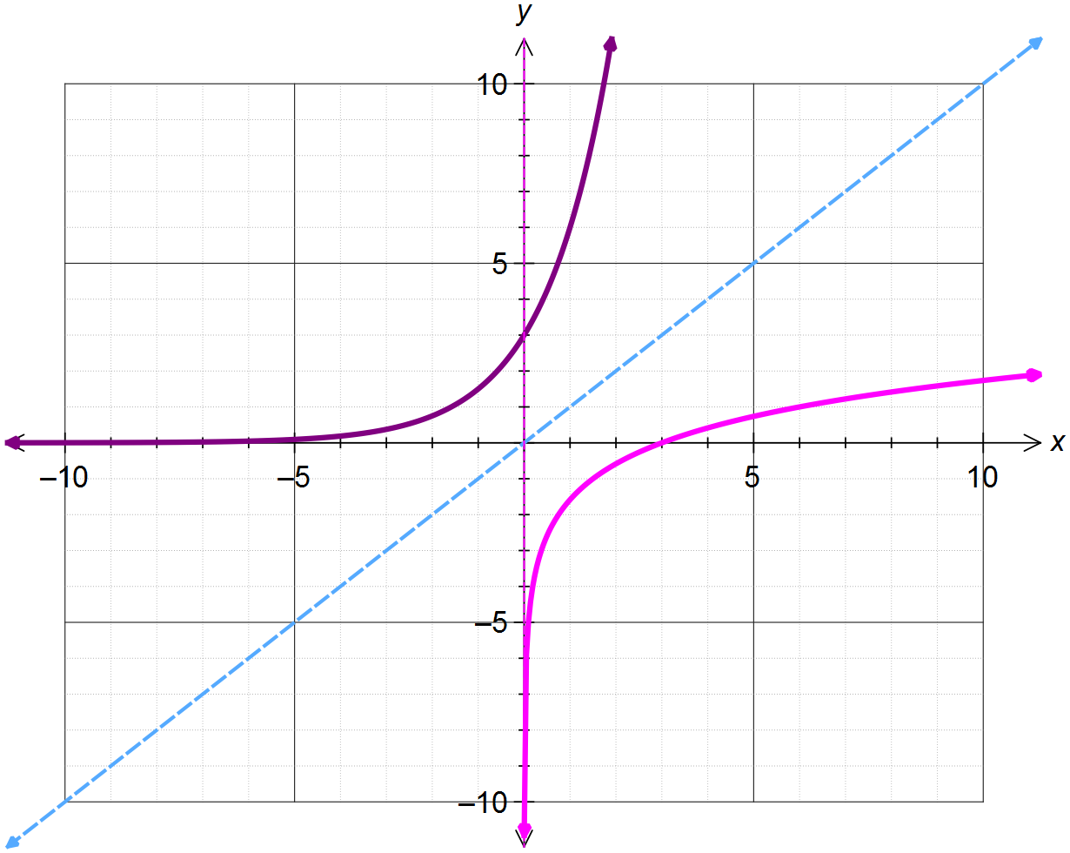





- State the equation of the exponential function in the form .




- Use the exponential graph drawn, and an appropriate mirror line, to draw the logarithmic function which is the inverse of the given exponential function.


- Hence or otherwise determine the equation of the logarithmic function, which is the inverse of the given exponential function with the same base.


Question Two: [2, 3, 3 = 8 marks] CF

Determine the equation of each of the following graphs drawn below:
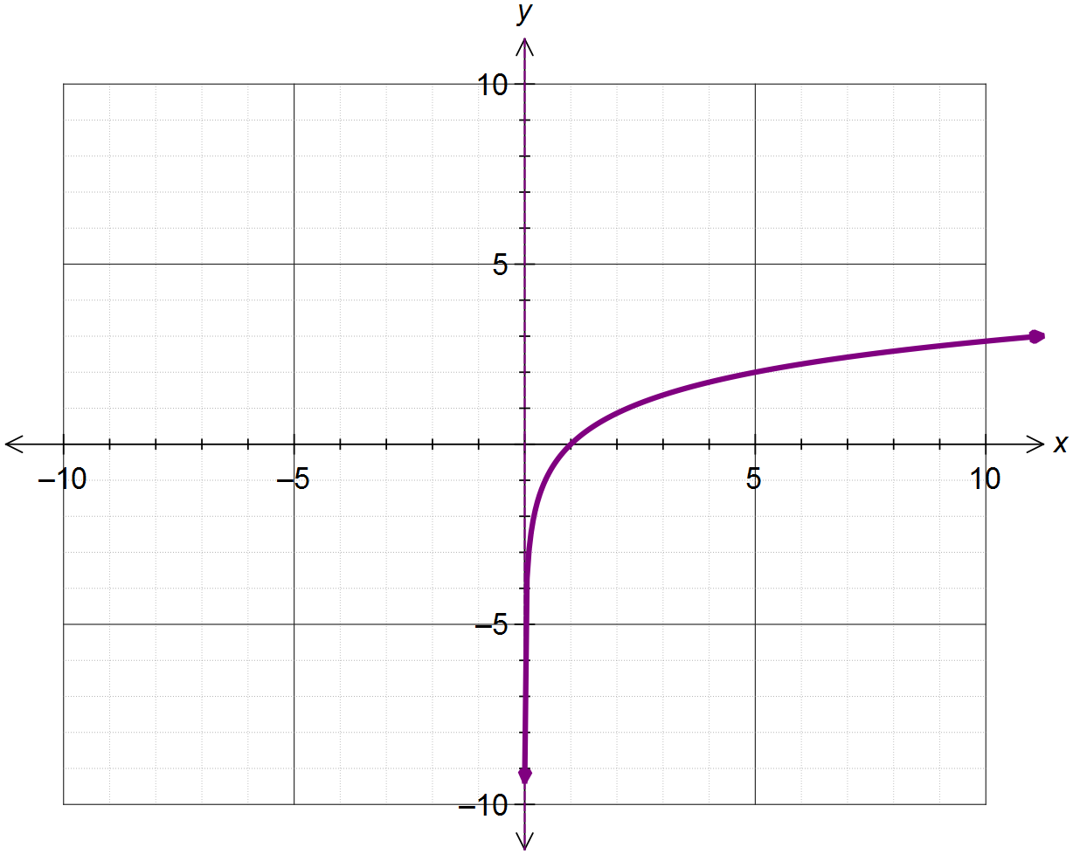




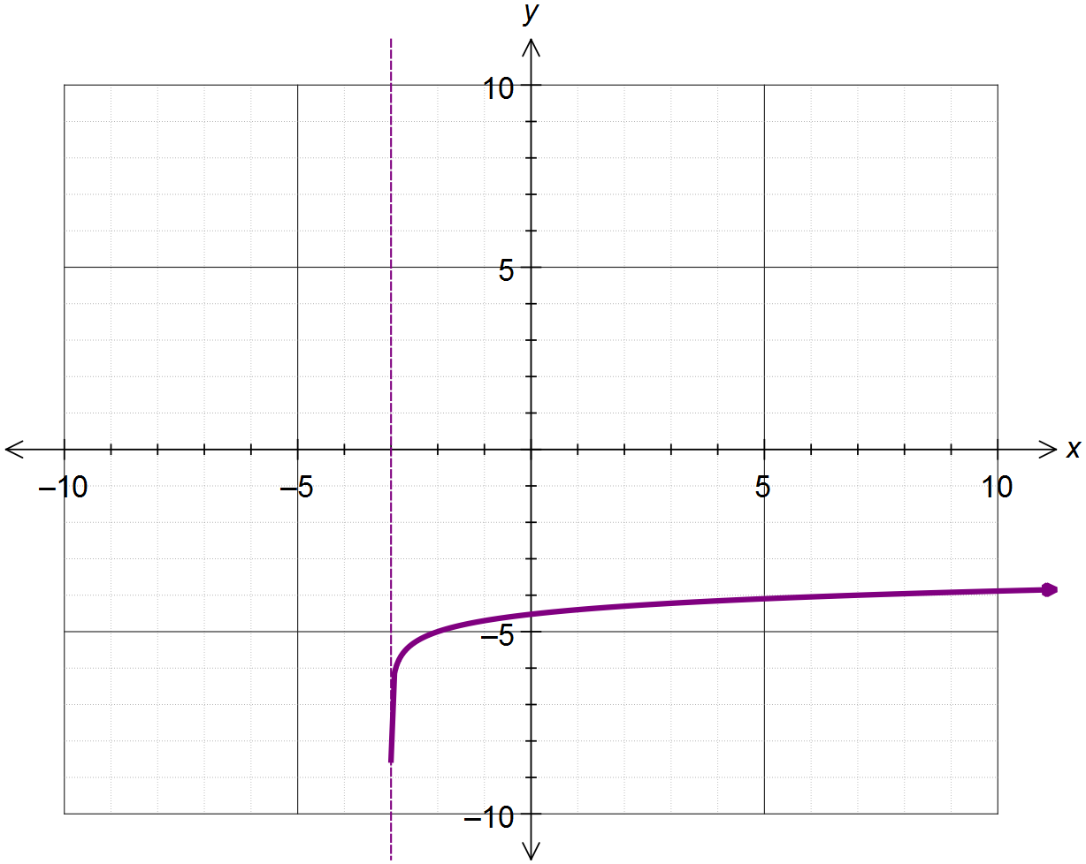

(b)





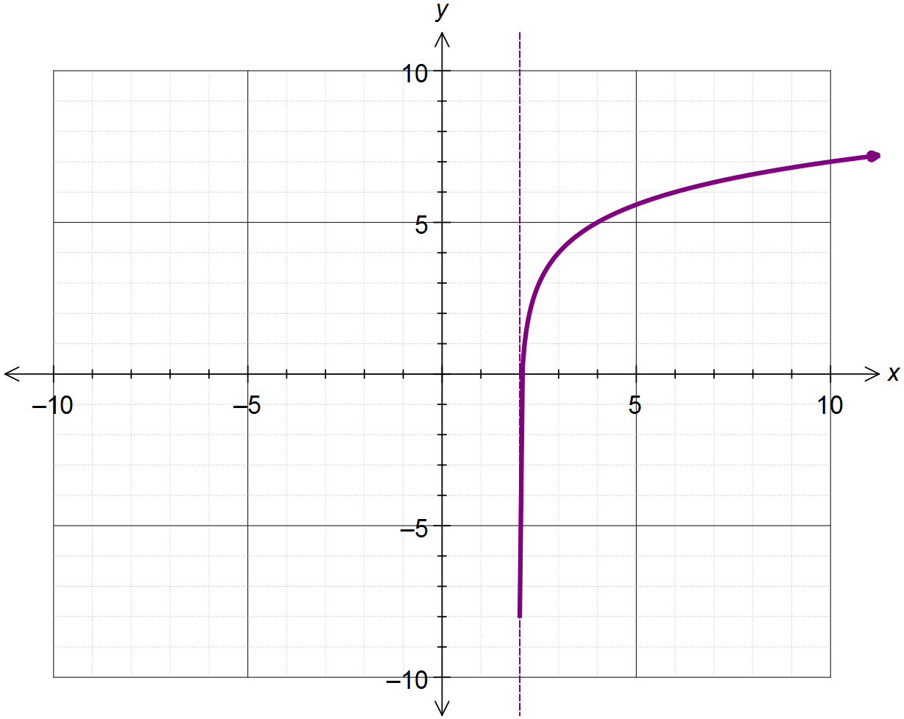(c)



Question Three: [2, 1, 2 = 5 marks] CF
The function is drawn below.


(a) Determine the value of a.



(b) Use the graph to approximate the solution to


(c) Solve algebraically.


Question Four: [1, 3, 3, 2, 3, 3 = 15 marks] CF

Differentiate each of the following with respect to x, showing full working:

(a)



(b)




(c)





(d)



(e)





(f)



Question Five: [5, 5 = 10 marks] CF

(a) Determine the coordinates of the point(s) where the curve has a gradient of 2.






(b) Determine the equation of the tangent to the curve at the point where . Leave your answers as exact simplified values.







